**ESS162 Lab3: Patterns of Greenhouse Gas emissions across CA**

**This is a work alone project, Due 11A Feb 1**

**Goals:**

You will be plotting and analyzing datasets that describe the spatial patterns of Greenhouse gas emissions across California, and will also run an online GHG footprint estimator to see how you fit in. The datasets are contained in a single zip file on the class website (Lab3.zip), which you will download and unzip into a single folder. You will be working with Google Earth Pro and Excel. The key datasets (and footprint estimator) are:

1. ghg_inventory_scopingplan_sum_ESS162.xlsx is an Excel spreadsheet that summarizes CA’s annual GHG emissions since 2000. The dataset is produced by CA’s Air Resources Board, as part of the state’s GHG management strategy
2. <https://coolcalifornia.arb.ca.gov/calculator-households-individuals> is an online GHG footprint estimator, which provides an estimate of your annual GHG contribution
3. CACO2.kmz is a Google Earth kmz image of the annual CO2 emissions across CA from the EDGAR project
4. CACH4_1.kmz is a Google Earth kmz image of the annual CH4 emissions across CA from the EDGAR project
5. CAN2O_2.kmz is a Google Earth kmz image of the annual N2O emissions across CA from the EDGAR project
6. CA_rice.kmz is a Google Earth kmz image of the fields where rice is grown in CA from the state’s Crop_Mapping_2014 dataset
7. NaturalGas_Pipelines_US_201804.shp is a shape layer of the distribution pipelines for natural gas across the US
8. Refineries5.kmz is a kmz file that locates the major refineries in CA
9. GHG locations.kmz is a series of pushpin locations that you will use in your writeup
10. Additionally, you will use Census_tract_clipped_2.shp from the first week of class

**Tools, steps and commands – same deal as last week**

Excel

Open ghg_inventory_scopingplan_sum_ESS162.xlsx

Sort by emission type

Calculate another table of the percent that each emission type contributes to the state’s total

Calculate the annual mean change in GHG emissions from that source using linest

Calculate the annual percentage change in GHG emissions from that source using linest/initial value

Google Earth Pro

Open and familiarize yourself with the various kmz and shp files. These kmz should already have their own embedded style templates and should open directly into Google Earth. The shp files will require that you setup a template (random colors is fine for the pipeline file). In general, red means higher emissions and green means lower.

**Writeup**

**What were 5 largest sources of GHG emissions in CA during 2016 and what fraction of CA’s total GHG emissions did the account for?**

The 5 largest sources of GHG emissions and the fraction of total 2016 emissions that they account for are, in order from largest to smallest: On Road (36.0172%), in-state electricity generation (9.85228%), refineries and hydrogen production (6.89561%), imported electricity (6.12137%), and residential fuel use (5.63696%).

**For each of these 5 largest sources include a 1-2 sentence description of what the source actually means (for example, if “Rail” was one of the top 5 (it isn’t, this is just an example), you would say something like Rail, which represents the emissions from railroads operated in CA, such as the CO2 produced by locomotives.**

“On Road” refers to vehicle emissions on roads, such as from cars and trucks that drive on roads as opposed to off road vehicles such as farm machinery. “In-state electricity generation” refers to the different sources of power within the state the produces GHG emissions. “Refineries and hydrogen production” refer to emissions associated with oil refineries, which often use fossil fuels to refine petroleum. “Residential fuel use” refers to the natural gas used in winter heating and for cooking in places of residence such as apartments or houses.

**What 4 sources have seen the greatest absolute reduction in emissions over the 20 years? Give an example of a policy that might have helped with each of these sources.**

These 4 sources and their absolute reduction from 2000 to 2016 are, in order from greatest reduction to lowest reduction: imported electricity (19.619798 MTCO2e), in-state electricity generation (16.640484 MTCO2e), On Road (10.116909 MTCO2e), and residential fuel use (5.185035 MTCO2e).

Policies that reduced power use (imported and in-state electricity generation) include the Energy Action Plan and the California Long Term Energy Efficiency Strategic Plan. The former recommended numerous actions that can be taken to increase energy efficiency – e.g. energy efficiency standards in appliances, requiring the utilities incorporate energy efficiency into their resource plans, etc – as well as actions to improve California’s renewable energy portfolio, while the latter recommends actions to increase energy efficiency in the power generation and natural gas sectors of the Californian economy. These plans might have led to decreases in emissions from imported electricity and in-state electricity generation.

The state also has a Climate Change Scoping Plan that is the overarching plan that reduces emissions through multiple approaches. The 2008 edition of this plan sets a goal of increasing the capacity of Combined Heating & Power (CHP) by 4000 MW by 2020. This might have led to an increased supply in heat that reduces residential fuel use in winter heating.

Policies that might have led to reductions in on road emissions seem to concentrate on improving the technology of vehicles and fuels. For example, AB 1493 (Pavley, Chapter 200, Statutes of 2002) instead the Air Resources Board to adopt standards that reduce vehicle emissions to the maximum extent **technologically feasible**. It is unclear if the state created policies that aimed to reduce the number of miles that vehicles drive.

**Calculate the state’s per capita GHG emissions in 2016 based on a population of 39.3 million.**

The state’s per capita GHG emissions in 2016 is 10.92 tons of CO2 equivalent.

**Compare the per capita mean with your footprint from the footprint estimator. How are you doing? What would the state’s GHG emissions be if had your GHG footprint? Include the screenshot of your C footprint (don’t worry, I’m not going to judge your “greenness” – I’m no “green” superstar myself).**

Before COVID

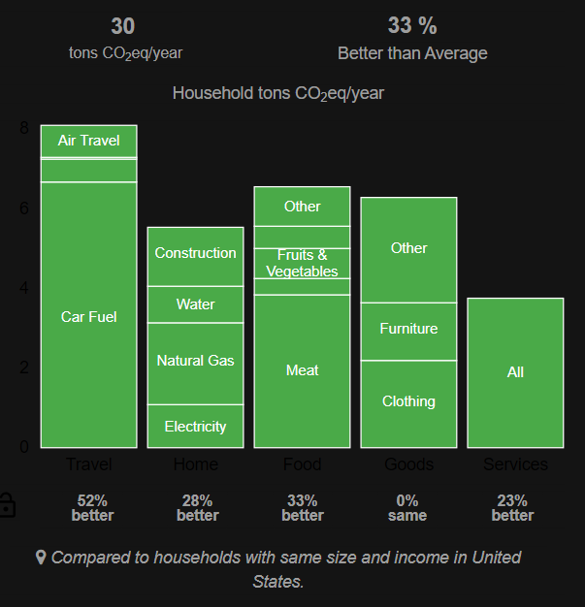

There are 4 people in my household, so on average, I release about 7.5 tons CO2e per year.

During COVID

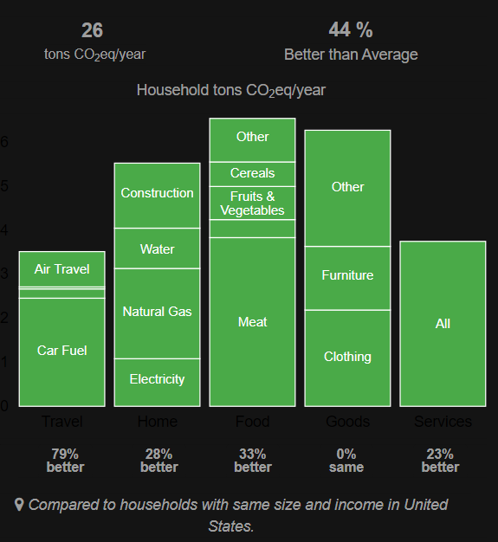

During the pandemic, I emit greenhouse gas emissions at a rate of roughly 6.5 tons CO2e per year.

According to the footprint calculator, I am emitting less emissions than the state average. If the rest of the state has the same carbon footprint as I do, then they would emit roughly 255,450,000 tons of CO2 equivalent in 2016, or roughly 255 MTCO2e in 2016, which is roughly 59.5% that of its 2016 emissions.

**Describe three things that clearly help explain the patterns of CO2 emission. Include images of the CO2 emissions across CA, along with any additional layers (roads, etc) that how the spatial correlation.**

CO2 emissions seem to be positively correlated with population and population density: they are especially high over the dense regions of LA and Orange Counties, San Diego, and the Bay region.

Note: this figure is taken from the first lab report

Note how regions with high population density seem to coincide with regions with high CO2 emissions. These are urban regions characterized by lots of vehicle traffic that causes high CO2 emissions.

This correlation between vehicle traffic CO2 emissions does not exist only in high population areas but also along freeways through less populated parts of the state, as shown below:

High CO2 emissions also occur where refineries are. This can be explained by several factors. Refineries tend to be in high-population areas that have high vehicular traffic. In addition, refineries also emit CO2 themselves in the refinery process. These factors seem to result in high CO2 emissions being correlated with refineries, as shown below:

**Describe three things that clearly help explain the patterns of CH4 emission. Include images of the CH4 emissions across CA, along with any additional layers (roads, etc) that how the spatial correlation.**

Methane emissions can be partly described by the presence of a certain form of agriculture known as concentrated animal feeding operations, which tend to occur in the Central Valley, a region whose economy is characterized by agriculture. These animal operations often raise cows, which releases methane through belching and help make the Central Valley a source of methane emissions.

There is another form of agriculture that is a significant source of CH4 emissions: rice farming. Rice paddies are flooded while rice grows, and the saturated conditions deprive soil microbes of oxygen; as a result, instead of producing CO2, soil microbes in rice paddies produce CH4.

Rice farming region

CH4 emissions in rice farming region with the same scale as the figure above

High methane emissions are also correlated with the presence of refineries. Refineries are a source of methane and emits methane through various means, such as by leakage from inadequate piping systems. However, although high methane emissions also tend to occur in heavily populated regions, I’m hesitant to link population with the geographic distribution of methane emissions.

**Describe two things that clearly help explain the patterns of N2O emission. Include images of the N2O emissions across CA, along with any additional layers (roads, etc) that how the spatial correlation.**

Nitrous oxide emissions seem to be especially high in the Central Valley, which is the breadbasket of California and produces roughly 40% of the produce in the US. As such, agriculture is particularly intense in this region, and crops are grown to (1) feed humans and (2) feed animals that would then feed humans. Suppose that growing crops only to feed the human population results in a certain amount A of food. According to basic principles of ecology, the amount of biomass tends to decrease as trophic levels increase. Therefore, to raise enough livestock to obtain the same amount A of meat requires growing animal feed crops that is many times the amount of A. Therefore, raising livestock requires very intensive agriculture. Such intensive agriculture accompanies intensive use of fertilizers, which would then be denitrified in soils to form the greenhouse gas nitrous oxide. Thus, the presence and type of agriculture helps to explain the geographic distribution of N2O emissions.

N2O emissions also seem to concentrate in population centers (i.e. LA and Orange Counties, San Diego, and the Bay area). Nitrous oxide emissions in these regions can be explained by vehicle emissions. The high temperatures of vehicle engines are high enough to fix the normally unreactive atmospheric N2 and produces N2O emissions as a result. The sheer population density of these population centers means lots of cars that lead to high N2O emissions.

**GHG locations.kmz includes 7 pushpins for locations that have either anomalously high or anomalous proportions of GHGs (for example, particularly high CH4 emissions for that general area, or particularly high CH4 emissions in the absence of significant CO2 emissions). For each of these locations summarize the relative CO2, N2O and CH4 emissions, explain why these emissions are anomalous (why that point stands out), and provide a brief explanation.**

Site 1. This location has very high N2O and CH4 emissions yet very low CO2 emissions. While this suggests that there may be a presence of concentrated animal feeding operations (leading to high CH4 emissions) and other forms of agriculture to feed these animal operations (leading to high N2O emissions), I could not find any animal feeding operations or farms.

Site 2. This location has relatively high N2O and CO2 emissions compared to CH4. Zooming in closer, I saw that this is a small town, which explains the pattern in emissions. The relatively high amount of vehicles in a relatively small space produces lots of CO2 and fixes N2 to form high amounts of N2O. There is a relative lack of CH4 emissions due to the lack of agriculture or refineries at this site.

Site 3. This site has high amounts of N2O and CH4 emissions relative to CO2 emissions. This can be explained by the fact that the main forms of land use at this site are different forms of agriculture: growing crops and raising livestock. The livestock serves as a source of methane emissions while the fertilization of crops make this site a significant source of N2O.

Site 4. This site has low emissions of N2O, CH4, and CO2. This location seems to be absolutely barren with no forms of land use in site. There are no urban forms of land use to release CO2 and N2O, and neither is there agriculture or animal operations to release N2O or, respectively, CH4.

Site 5. This is the Salton Sea, and this site has low CO2 emissions and high N2O and CH4 emissions. While high N2O and CH4 emissions initially led me to thinking that this region has intensive agriculture that led to high N2O and CH4 emissions, the fact that the pixels over the Salton Sea itself, not most of the surrounding Imperial Valley, indicates that these emissions are not from agriculture. The Salton Sea is the site of decades-long environmental justice issues that stemmed from the diversion of water in the lake to LA, San Diego, and other urban areas. This gradually decreased the size of the lake while also increasing salinity. I presume that this increasing salinity killed fish and primary producers such as phytoplankton, which deprives the water in the lake of oxygen. This lack of oxygen and the amount of dead biological organisms drives anaerobic decomposition that produces high N2O and CH4. Since the Salton Sea is surrounded by farmland in the Imperial Valley, nitrogen-rich runoff could have ran off into the lake, forming a source of nitrogen that leads to N2O emissions in the lake itself.

Site 6. This site has relatively high amounts of N2O and CH4 emissions, but has much higher CO2 emissions. Closer examination on Google Earth seems to suggest the presence of oil jacks. I presume that some form of combustion fuels these jacks, leading to high CO2 emissions. The combustion can also explain N2O emissions in the same manner that car engines produce N2O: high combustion temperatures might have fixed N2. CH4 emissions can be due to the leakage of natural gas from the jacks.

Site 7. This site has relatively low emissions for all 3 gases. Because it is close to a freeway, it still has relatively higher CO2 emissions than sites further away from the freeway. However, because there are no urban areas nearby, there are no lingering cars and no high concentration of cars to produce high CO2 emissions. The lack of any other forms of intensive land use results in low CH4 and N2O emissions.